*Florida International University*

*School of Computing and Information Sciences*

CIS 4911 - Senior Capstone Project

Software Engineering Focus

Feature Document

User Story # 703

**Team Member:**

Garrett Lemieux

**Product Owner(s)**:

Francisco Ortega

**Mentor(s)**:

Francisco Ortega

**Instructor**: Masoud Sadjadi

**User Story – Implement Additional Gestures for Real Sense**

* As a user I would like to be able to perform additional Gestures in order to allow more interaction with paint program using Real Sense device.
* **Acceptance Criteria**:
  1. Create new gestures.
  2. Each gesture must perform a different function.

**Use Case**

User wants to perform additional facial gestures that will perform more operations within Interactive paint program.

* Details:
* Actor:
  + User
* Pre-conditions:
  + TouchPoint app is running.
  + Real Sense Device
* Description:
  + Use case begins when User has decided to perform face gesture.
  + User can toggle symmetry mode by performing a tongue gesture.
  + User can change current drawing color by performing a cheek gesture.
  + User can change current drawing shape by performing a smile gesture.
  + Use case ends when user is provided feedback for function performed when facial gesture was read.
* Post-conditions:
  + TouchPoint app is running
  + Real Sense device connected and user is provided feedback that desired function was performed.
* Decision Support:
  + Frequency: Medium, User may want to change modes using Real Sense facial gesture but can also perform same undo function using touch screen or leap motion.
  + Criticality: Medium, Other devices can perform these functions.
  + Risk: High , First time working with Real Sense
* Usability:
  + Needs to know how a cheek gesture is performed.
  + Needs to know how a smile raise gesture is performed.
  + Needs to know how a tongue gesture is performed.
  + Needs to know what function the gestures perform.
* Reliability
  + High
* Performance
  + Performance High
  + Failure Low
* Supportability
  + Real Sense Device
* Modification History:
  + Owner: Garrett Lemieux
  + Initiation Date 4/5/2016
  + Date last Modified: 4/16/2016

**Use Case Diagram**

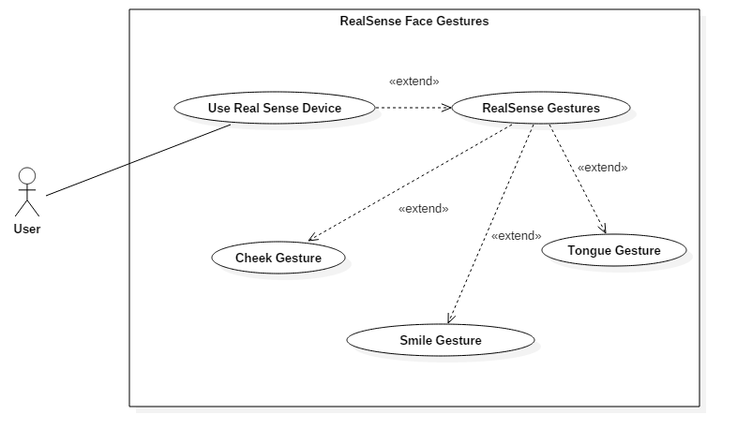

**Sequence Diagram**

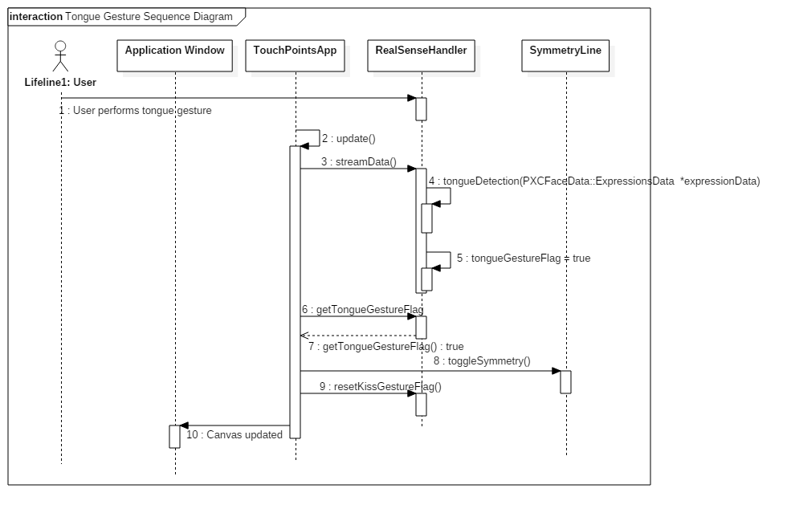

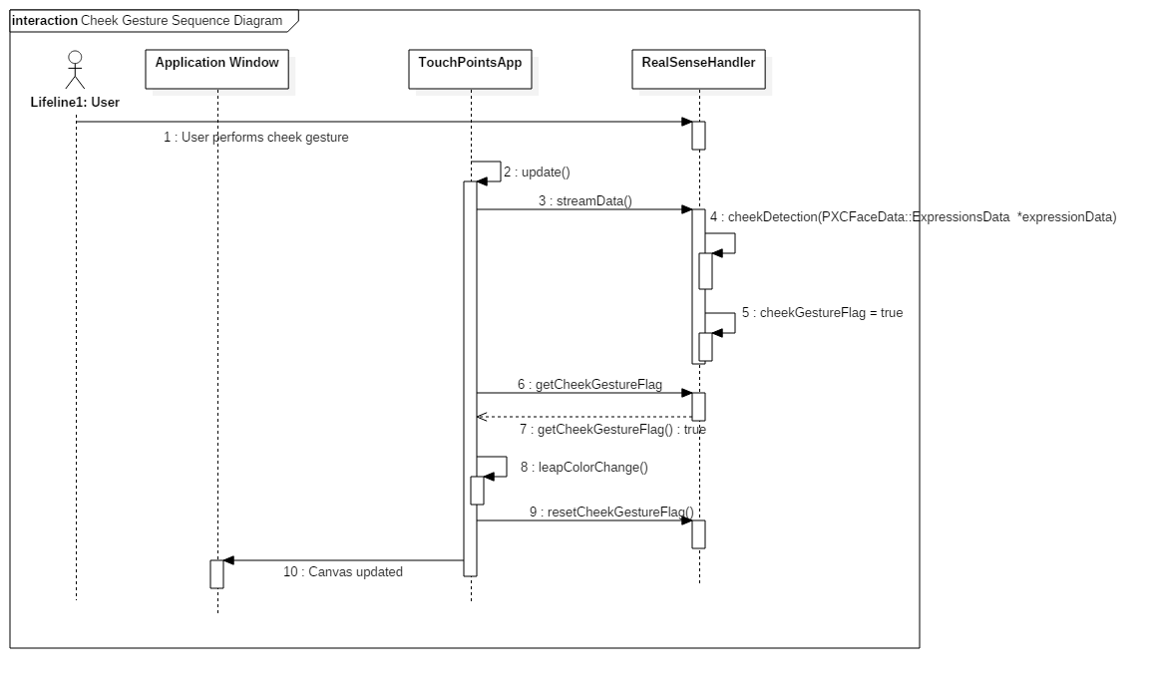

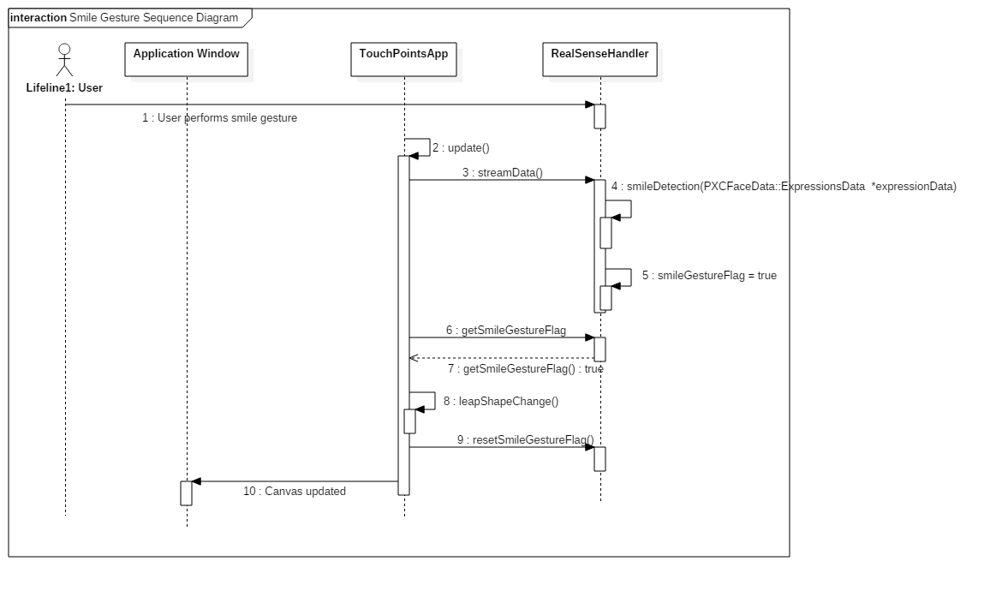

**Class Diagram**

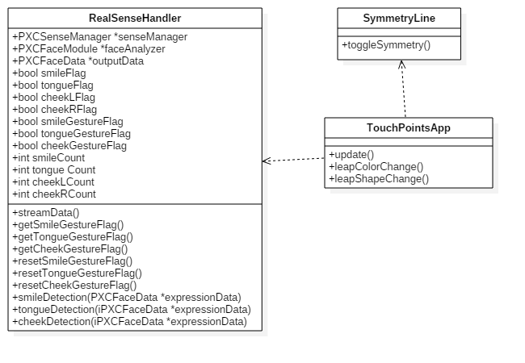

**Unit Test**

* Sunny Day Test:
  + Test Case  - Tongue Gesture Read by Real Sense
    - Test Purpose: To determine if Real Sense correctly reads tongue gesture.
    - Test Procedure: User starts program. He or she then performs a tongue gesture and holds gesture for at least one second. Observes results the feedback and then draws a line on the left side of the canvas.
    - Expected Results: After tongue gesture performed the symmetry line should appear on the canvas. When the user begins to draw on the left side of the screen an identical line should appear on the right side of canvas.
  + Test Case  - Cheek Gesture Read by Real Sense
    - Test Purpose: To determine if Real Sense correctly reads cheek gesture.
    - Test Procedure: User starts program and draws a line with the current color. He or she then performs a cheek gesture and holds gesture for at least one second. Observes results and then draws a second line.
    - Expected Results: The user should first see a drawn line with the current color setting. After cheek gesture performed feedback should be given to the user in the form of a square with the new color setting. Once the user draws a second line the new color should be seen.
  + Test Case  - Smile Gesture Read by Real Sense
    - Test Purpose: To determine if Real Sense correctly reads smile gesture.
    - Test Procedure: User starts program and draws a line with the current shape setting. He or she then performs a smile gesture and holds gesture for at least one second. Observes results and then draws a second line.
    - Expected Results: The user should first see a drawn line with the current shape setting. After smile gesture performed feedback should be given to the user in the form of a square with the new shape setting. Once the user draws a second line the new shape should be drawn.
* Rainy Day Test:
  + Test Case  - User Accidently performs tongue gesture
    - Test Purpose: Test if accidental tongue gesture is read by Real Sense.
    - Test Procedure: User starts program and draws one line. He or she then performs a quick tongue gesture that lasts less than one second. Then User attempts to draw another line.
    - Expected Results: The first line drawn should appear in specified location. After tongue gesture nothing should happen and canvas should not be altered. When user draws a second line an identical line should not be drawn anywhere else on the canvas.
  + Test Case  - User Accidently performs cheek gesture
    - Test Purpose: Test if accidental cheek gesture is read by Real Sense.
    - Test Procedure: User starts program and draws one line. He or she then performs a quick cheek gesture that lasts less than one second. Then User attempts to draw another line.
    - Expected Results: The first line drawn should appear in specified location with current color setting. After cheek gesture nothing should happen and canvas should not be altered. When user draws a second line drawn line should be same color as previously drawn line.
  + Test Case  - User Accidently performs smile gesture
    - Test Purpose: Test if accidental smile gesture is read by Real Sense.
    - Test Procedure: User starts program and draws a shape. He or she then performs a quick smile gesture that lasts less than one second. Then User attempts to draw another shape.
    - Expected Results: The first shape drawn should appear in specified location with current shape setting. After smile gesture nothing should happen and canvas should not be altered. When user draws a second shape, the shape drawn should be same as previously drawn shape.

**Integration Testing**

* The ability to use the smile, cheek, and tongue gestures with Real Sense while all devices are connected was successful.
* The smile gesture was used to change the current shape setting being used to draw. After performing smile gesture the current shape setting was changed. The Leap motion and Multitouch were used to draw and successful drew the new shape.
* The cheek gesture was used to change the current color setting being used to draw. After performing cheek gesture the current color setting was changed. The Leap motion and Multitouch were used to draw and successful drew the new color.
* The tongue gesture was used to turn on the symmetry mode. After performing the tongue gesture both the leap motion and multitouch were able to draw symmetry lines and shapes.
* After integrating smile, cheek, and tongue gestures into the application all previous functionality was maintained and functioning correctly.

**User Guide**

* Devices Used: Acer Multitouch and Real Sense Device and Leap Motion

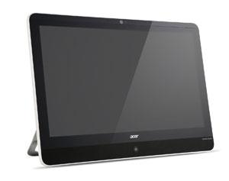

* Acer - Multitouch

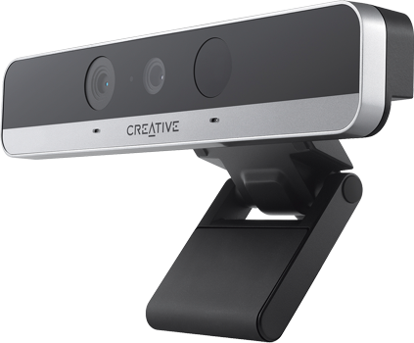

* RealSense Device

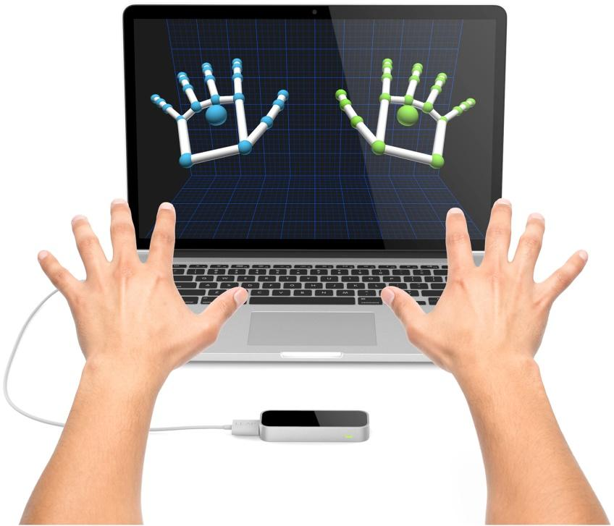

* Leap Motion
* User must have the Real Sense plugged in.
* The user can perform a smile gesture as shown below.
* Before Gesture:

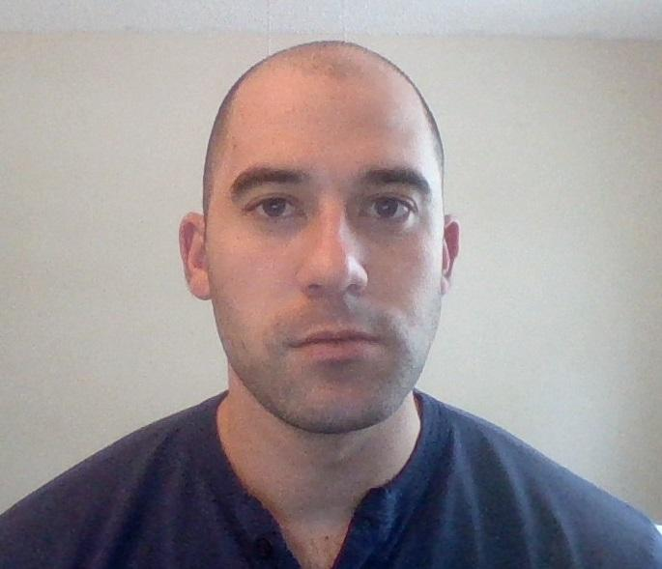

* Kiss Gesture:

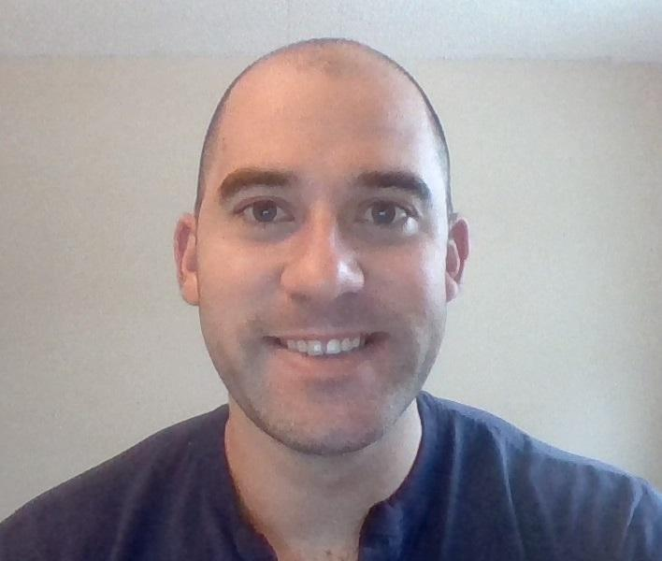

* Once the user holds the gesture for at least one second the shape setting will be changed.
* The user can perform a cheek gesture as shown below.
* Before Gesture:



* Double Eyebrow Raise Gesture

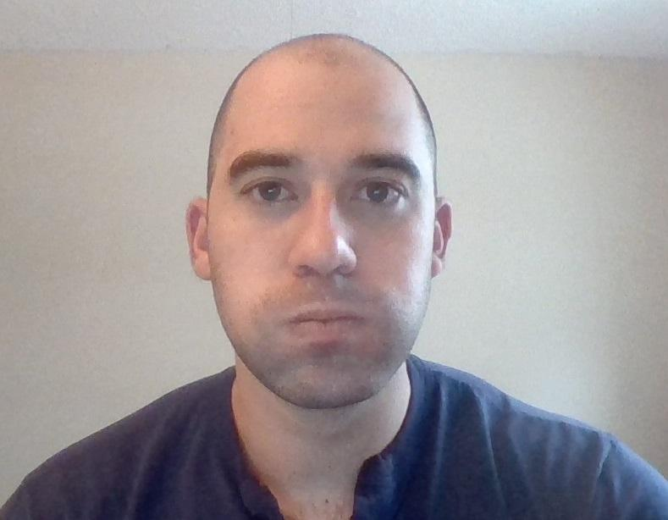

* Once the user holds the gesture for at least one second the color setting will be changed.
* The user can perform a tongue gesture as shown below.
* Before Gesture:



* Double Eyebrow Raise Gesture

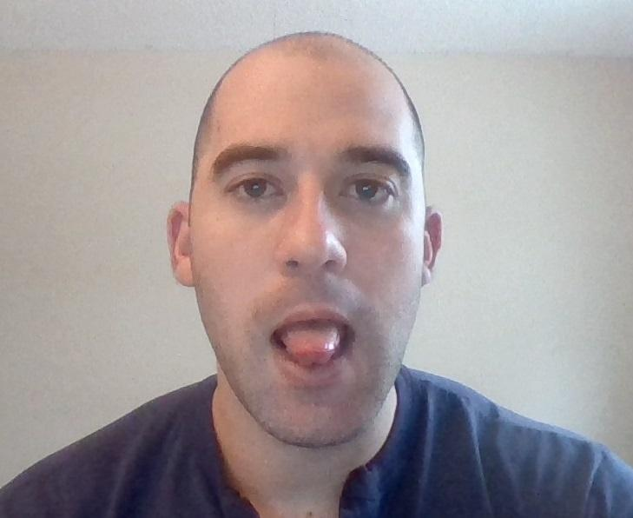

* Once the user holds the gesture for at least one second the symmetry mode will be toggled on or off.

**Glossary**

* **Real Sense Device -** Real Sense uses three different cameras. One acts like a 1080p hd camera, the second an infrared camera, third an infrared laser projector. These three cameras allows the real sense to view similar to how the human eye would. It tracks both depth and physical motion.
* **Real Sense Gesture -** Real Sense Device uses infrared cameras to track specific landmarks on a person's face. It then interprets whether a gesture was performed.